## **Sprint Plan #4 — Kondition (May 21 - June 3)**

### **Goal**

Enable users to track personal bests, have motivational quotes with custom reminders, and a feed where they can post achievements and stats.

### **User Story 1**

**“As a user, I want to track my personal bests”**

* Define fields (e.g., exercise name, best weight, best reps, best time, date achieved) (3 hours)
* Create endpoints to retrieve personal bests. (2 hours)
* Implement logic to calculate/update personal bests automatically when a new workout is logged. (3 hours)
* Create personal bests section (e.g., dashboard, cards, or charts). (2 hours)
* Display personal bests per exercise. (1 hour)
* Fetch and display personal bests from backend dynamically. (2 hours)
* Define & Expose PB Endpoint (2 hours)
* Design PB Display UI (3 hours)
* Fetch & Render PB Data (2 hours)
* Develop logic for identifying personal bests based on workout logs (3 hours)

**Total for user story 1: 23 hours**

**User Story 2**

**“As a user, I want motivational quotes and custom reminders”**

* Design UI for: Displaying daily/random motivational quotes. Managing (create/edit/delete) custom reminders. (5 hours)
* Implement UI components for quote display and reminders management. (2 hours)
* Connect the frontend to backend APIs for quotes and reminders. (2 hours)
* Integrate push notifications or local notifications for reminders. (2 hours)
* Implement user settings for enabling/disabling reminders (1 hour)
* Setup backend to receive and send reminders and quotes (3 hours)
* Setup Custom workout reminders (2 hours)
* Display the Quotes in notifications tab (2 hours)

**Total for user story 2: 19 hours**

**User Story 3**

**“As a user, I want to see a feed of followed users”**

* Design the feed UI layout (1 hour)
* Create backend schema to store user follow relationships (3 hours)
* Develop API to fetch workout/activity posts from followed users (2 hours)
* Implement frontend logic to display the feed and refresh on pull/load (3 hours)
* Write unit tests for feed generation logic(2 hours)
* Create User Profile Screen (2 hours)
* Implement Follow/Unfollow Button Logic (1 hour)
* Build a Searchable Users List (3 hours)
* Fetch & Display the Feed (2 hours)

**Total for user story 3: 19 hours**

## **Team Roles**

* **John Gmuender**: Product Owner, Developer
* **Shayna Das**: Developer
* **Kush Khanna**: Developer
* **Edward Zhou**: Developer
* **Andy Vo**: Developer
* **Akash Srinivasan**: Scrum Master

## **Initial Task Assignment**

* **John Gmuender**: User Story 3 – Design the feed UI layout, Create backend schema to store user follow relationships, Develop API to fetch workout/activity posts from followed users, Write unit tests for feed generation logic, Implement Follow/Unfollow Button Logic, Build a Searchable Users List
* **Shayna Das**: User Story 1 – Develop logic for identifying personal bests based on workout logs; User Story 2 – Display the Quotes in notifications tab; User Story 3 – Fetch & Display the Feed
* **Kush Khanna**: User Story 1 – Define fields (e.g., exercise name, best weight, best reps, best time, date achieved), Create endpoints to retrieve personal bests, Implement logic to calculate/update personal bests automatically when a new workout is logged, Create personal bests section (e.g., dashboard, cards, or charts), Display personal bests per exercise, Fetch and display personal bests from backend dynamically, Define & Expose PB Endpoint, Fetch & Render PB Data, Develop logic for identifying personal bests based on workout logs, Create endpoints to calculate and retrieve personal bests
* **Edward Zhou**: N/A
* **Andy Vo**: User Story 1 – Create personal bests section (e.g., dashboard, cards, or charts), Design PB Display UI, Design UI for: Displaying daily/random motivational quotes; User Story 2 – Managing (create/edit/delete) custom reminders, Implement UI components for quote display and reminders management, Connect the frontend to backend APIs for quotes and reminders, Integrate push notifications or local notifications for reminders, Setup backend to receive and send reminders and quotes, Setup Custom workout reminders, User Story 3 – Create User Profile Screen, Design the feed UI layout
* **Akash Srinivasan**: User Story 1 – Implement logic to calculate/update personal bests automatically when a new workout is logged, Fetch and display personal bests from the backend dynamically.

## **Initial Burnup Chart**

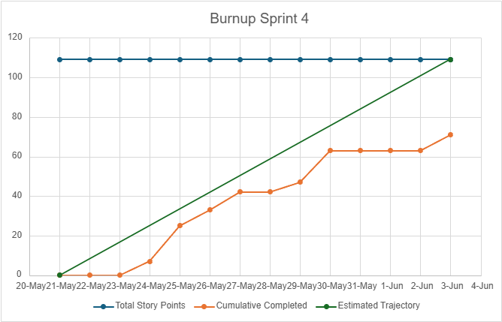

## **Initial Scrum Board**

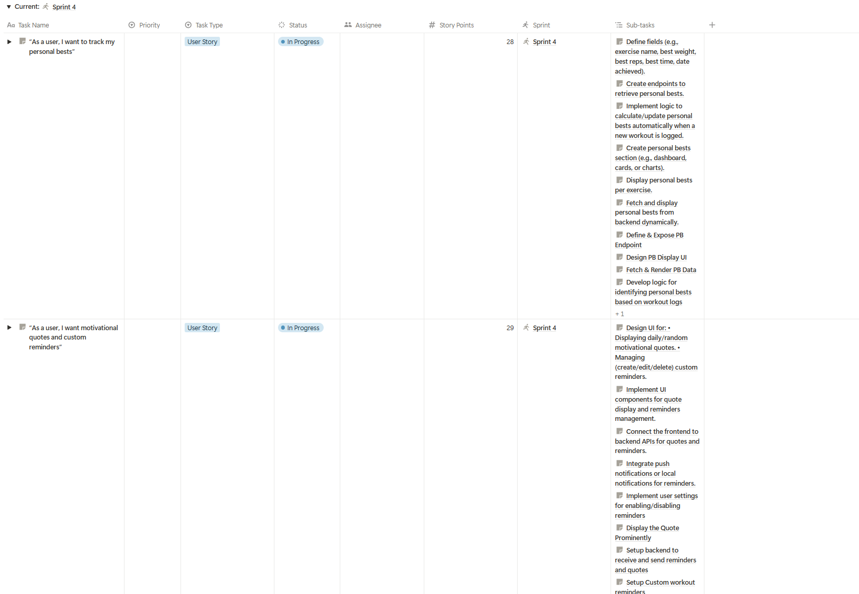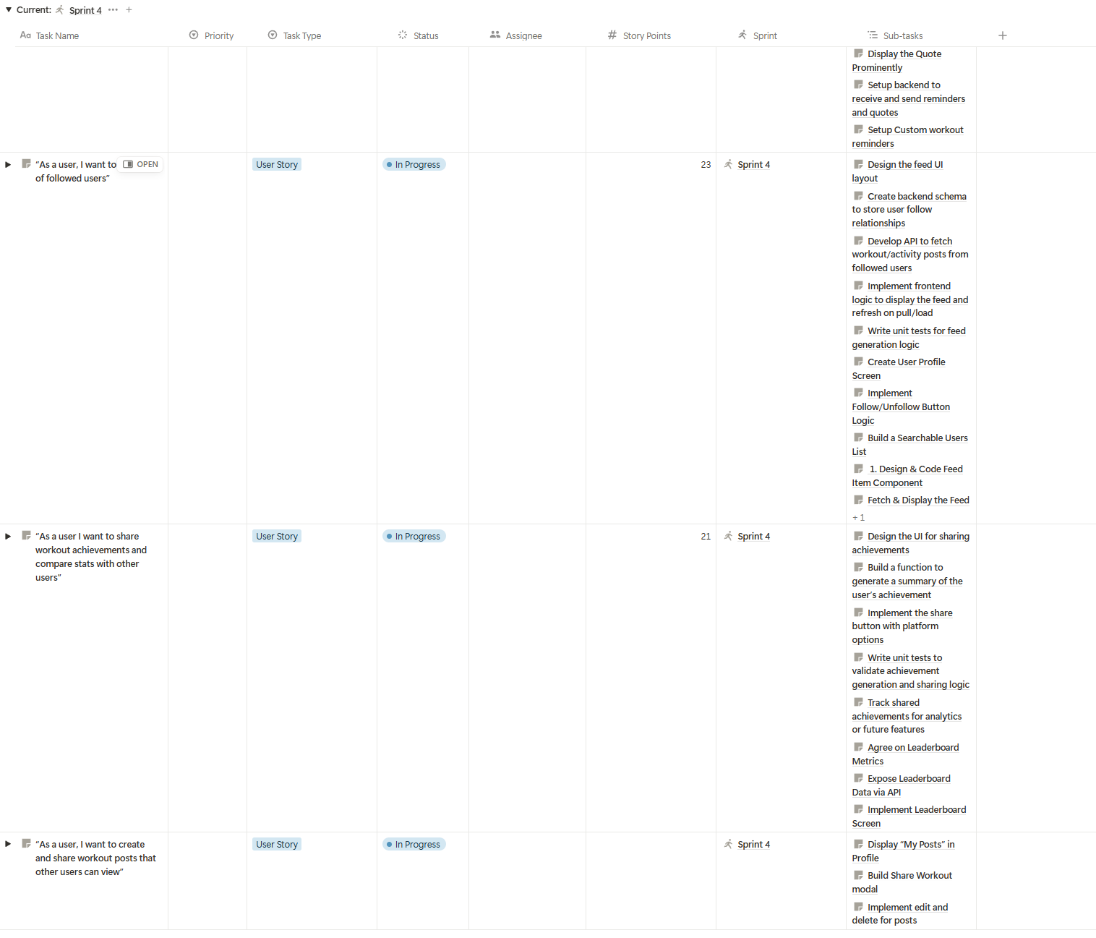

## **Scrum Times**

* Monday, 3:00 PM – 3:15 PM (TA/tutor present)
* Wednesday, 3:00 PM – 3:15 PM
* Friday, 3:00 PM – 3:15 PM